SQL USE CASE
Online Food Delivery Platform
You are working as a SQL Developer for FoodExpress.
The company wants analytical reports on customers, restaurants, orders, and delivery performance. You need to write SQL queries and optimize reporting operations

- Customers
Column Name Data Type Description
customer_id INT Primary Key
first_name VARCHAR Customer first name
last_name VARCHAR Customer last name
email VARCHAR Unique email
city VARCHAR Customer city
signup_date DATE Registration date
referred_by INT Refers to another customer_id

2. Restaurants
Column Name | Data Type
restaurant_id | INT
restaurant_name | VARCHAR
cuisine_type | VARCHAR
city | VARCHAR
rating | DECIMAL

3. Orders
Column Name | Data Type
order_id | INT
customer_id | INT
restaurant_id | INT
order_date | DATE
delivery_date | DATE
order_status | VARCHAR
payment_mode | VARCHAR
total_amount | DECIMAL

4. Delivery_Partners
Column Name | Data Type
partner_id | INT
partner_name | VARCHAR
city | VARCHAR
joining_date | DATE
manager_id | INT
rating | DECIMAL
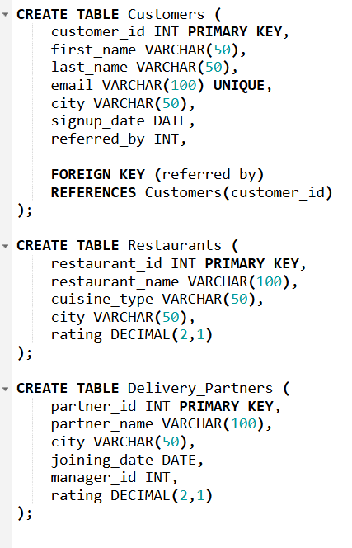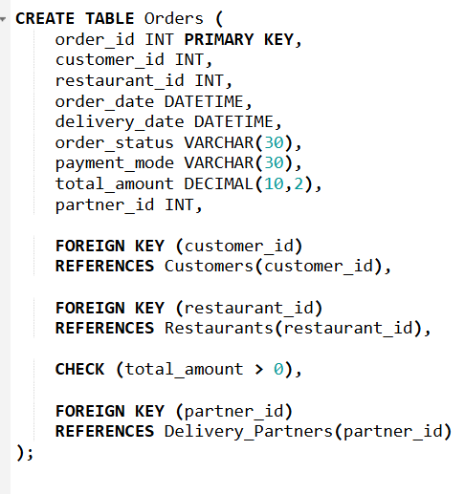
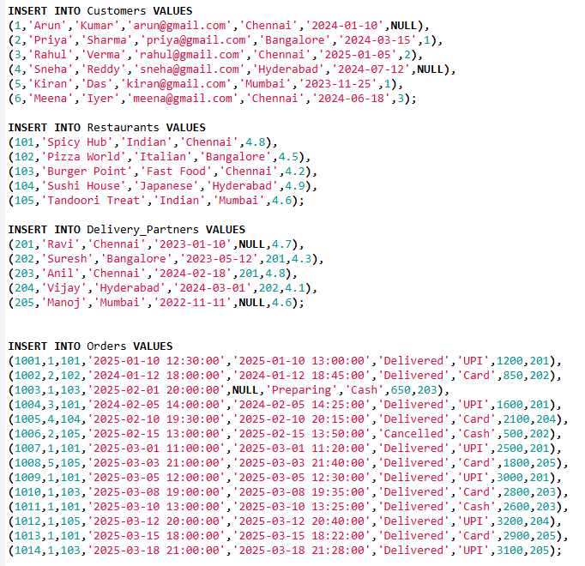

- Display all restaurants from Chennai ordered by highest rating.
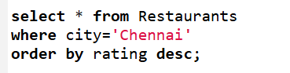
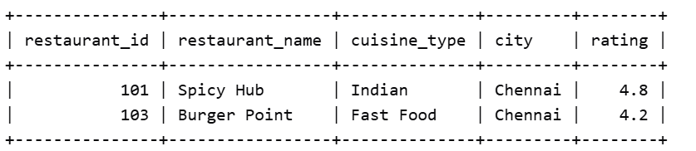

- Find all order which are placed after January 1,2025, amount greater than 1000 and status is not Cancelled
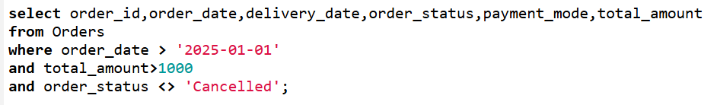
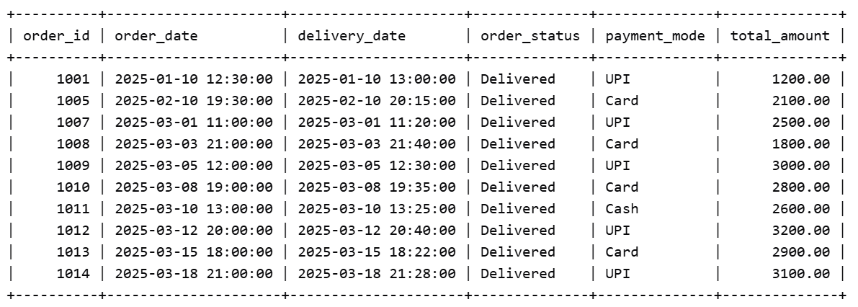

- Find customers who never placed any order.
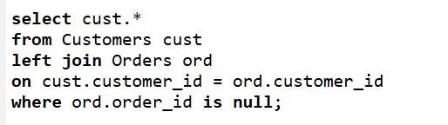
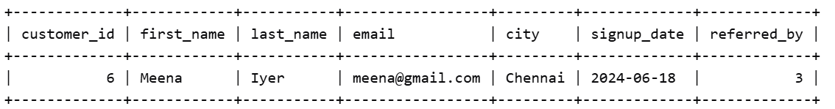

- In the table some delivery_date values are NULL. Display order_id, delivery status. If delivery date is NULL show it as “Pending Delivery”

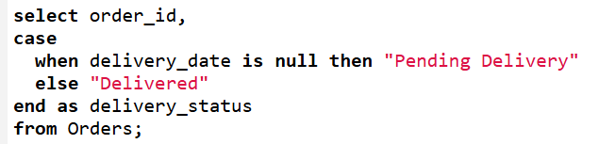
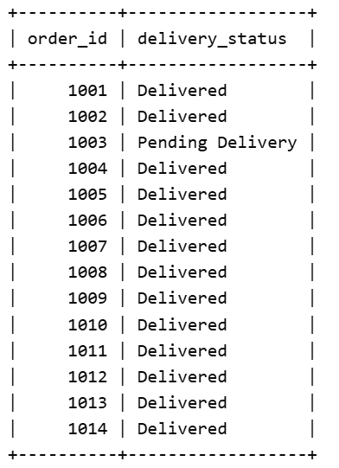

- The marketing team wants customers who: signed up in 2024, placed more than 5 orders, spent more than 15,000
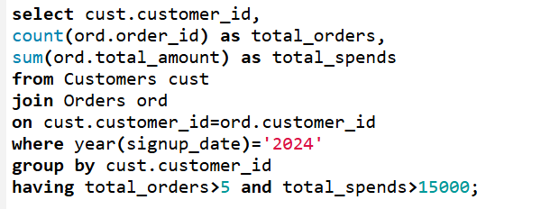
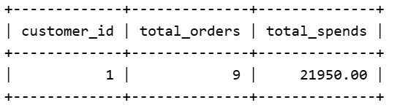

- Find customers whose order amount is greater than their own average order value.
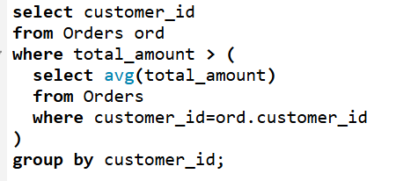
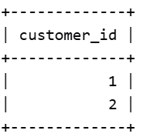

- Display latest order for each customer
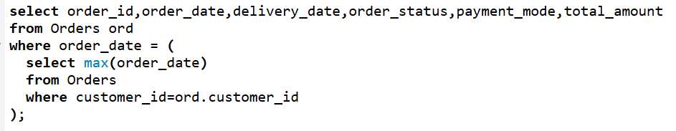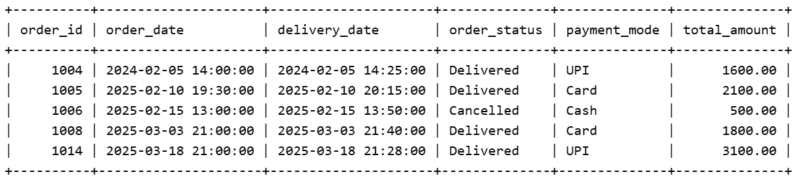

- Compare a customer’s current order amount with previous order amount and show the difference in the amount
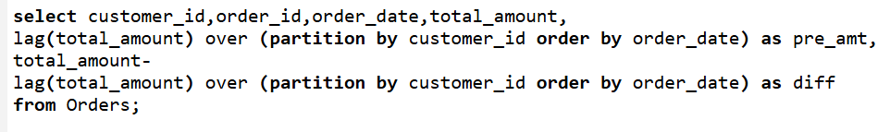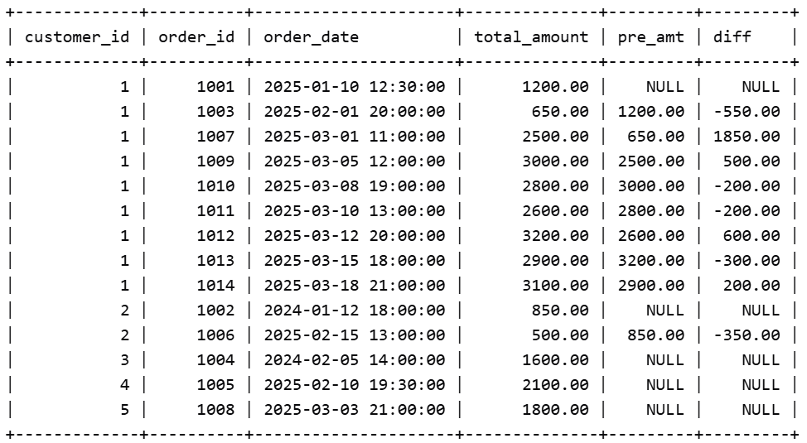

- Write SQL statements to add: PRIMARY KEY, FOREIGN KEY, UNIQUE constraint, CHECK constraint

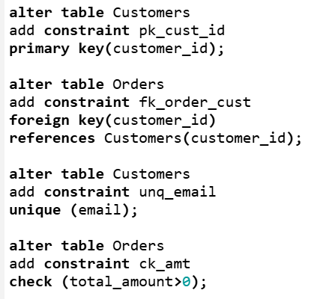

- Use a CTE to find top 5 customers based on spending.

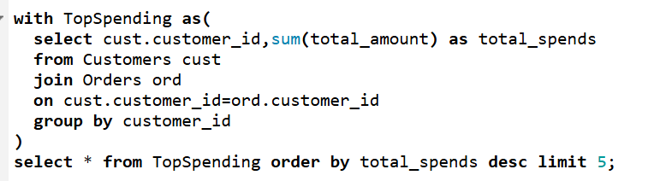

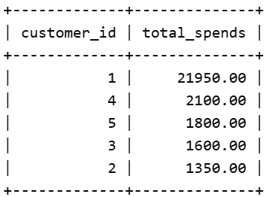

- Find the number of days between consecutive orders for each customer.
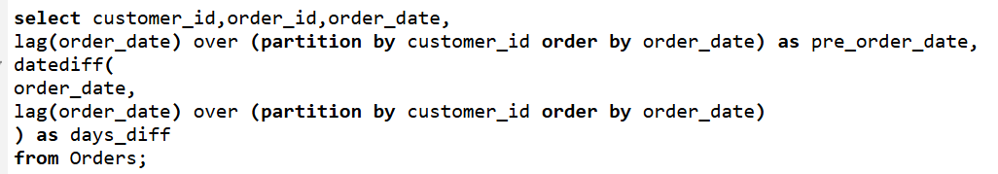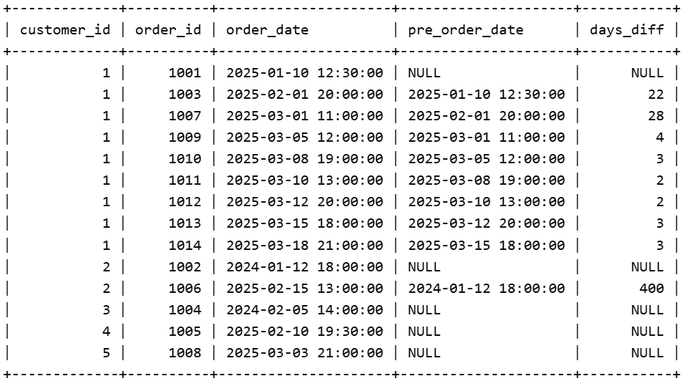

- Find the hour during which each restaurant receives maximum orders.
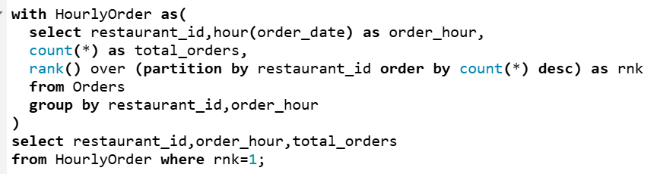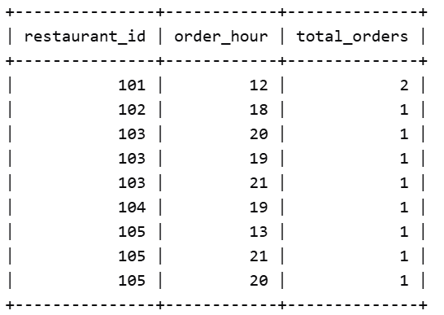

- Find the highest revenue-generating restaurant each month.
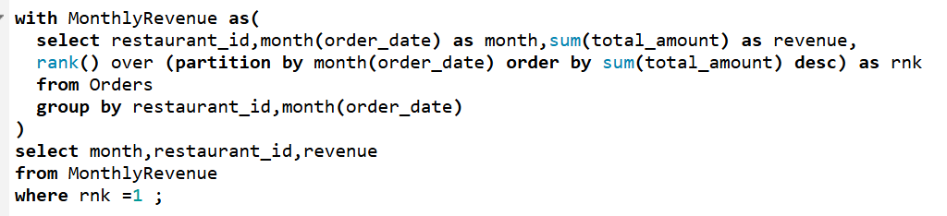
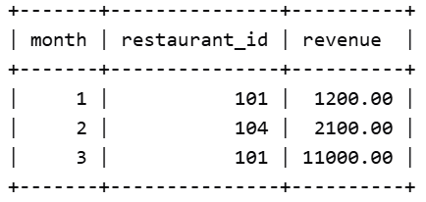

- Create a report showing: partner_name , total deliveries , avg delivery time , rank within city , performance category
Performance Rules:
Avg delivery < 20 mins → Excellent
20–40 mins → Good
40 mins → Poor
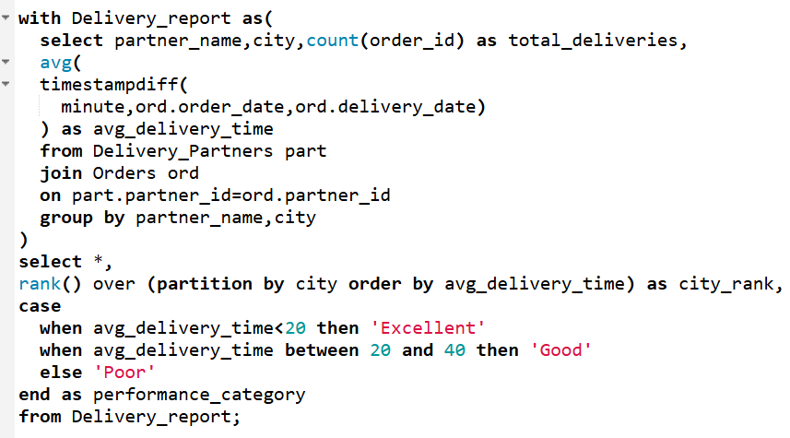
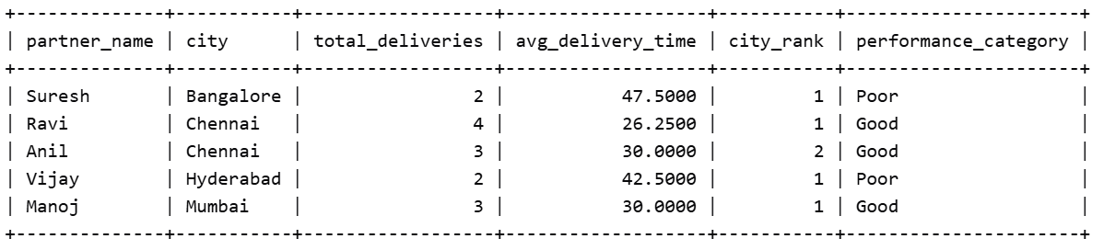

- Find what percentage of total company revenue each restaurant contributes. Return restaurant_name, total_revenue, contribution_percentage
